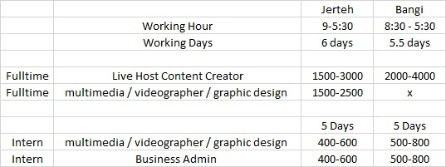

Business Admin/Masscom
- Building up the communities across the various social pages.
- Growing the engagement with fans, followers of the various pages.
- Brainstorming ideas and pulling teams together to discuss shoots, angles and ways to communicate to audiences and bringing them into the brand’s universe.
- Showing up every day with the mission in mind of growing and serving your clients and teammates in everything you do.
- Have experience creating content for own social profiles or freelance work.
- Must love to work in a high growth startup environment.
- Passionate & love video production
- Knowledge & experience in creating content for TikTok and Instagram.
- Knowledge & Experience in shooting video content and editing.
- Have good understanding of social media platforms (Facebook, YouTube, Instagram, TikTok) and various digital content distribution channels.
- Passionate about social media and interested in the latest trends.
- Positive attitude with good communication skills in English and Malay.
- Must have high sense of responsibility & accountability.
- Friendly, positive, cheerful and fluent in speaking.
- Knowledge in homecare, cooking, fashion lifestyle topics is an added advantage.
- Must have a unique combination of humility (willing to do the dirty work) and ambition (vision for what your future holds)

Multimedia/Videographer/Graphic Design

Job Description
- Work closely with the marketing team in creating design and content for brand awareness on social media
- Work closely with the project team in designing the look and feel of the system for demo purposes
- Monitor and analyse market trends and update weekly report on digital marketing performance of social media
- Ad-hoc assignment from time to time
Requirements: -
- Currently pursuing Bachelor's Degree in related field
- Self-motivated, enthusiastic, independent, and resourceful
- Good communication in English and Malay
- Able to collaborate well with team members
- Skilled in Canva, Photography, Videography, Photoshop, Capcut and other relevant tools

Score (100)
NAME

Resume (20)
artwork (10)
video editing (15)

Interview question
1. Introduce urself (10)
2.Curriculum jawatan apa (20)
3. Review 1 product dalam style titkok : (Total 25)
apa yg kamu boleh buat?

Score (15/20)
1. Creating graphics including illustrations, logo, layouts, photo (5)
2. ⁠Assist in creating content on social media (5)
3. Analyse market trend on social media (5)
4. ⁠how you Brainstorming and work with team in design (5)

Elaun 500-800
Tempoh internship :

1. https://www.facebook.com/groups/besutterengganu2/

2. https://www.facebook.com/groups/290700267771831/

3. https://www.facebook.com/groups/203331486904629/

4. https://www.facebook.com/groups/3030919180375468/

